

**ISOLATION AREA MANAGEMENT SYSTEM**

**Software Requirement Specification**

– Hanoi, January2022 –

**Table of Contents**

**I. Overview** **3**

1. Introduction 3

2. System Functions 4

2.1. Screen Flow 4

2.2. Screen Details 4

a. User 4

b. Nurse 4

c. Doctor 4

c. Admin 5

2.3. User Authorization 5

2.4. Non-Screen Functions 6

3. Common Requirements 6

3.1. User Requirements 6

Actors 6

Use cases 6

**II. Functional Requirements** **6**

1. <<Feature Name 1>> 6

a. <<Function Name 1>> 6

b. <<Function Name 2>> 7

2. <<Feature Name 2>> 7

# 

# 

# 

# 

# 

# 

# I. Overview

## 1. Introduction

The centralised isolation area management system was built with the requirements of easy operation and full of basic features of an administration system. Thanks to this system, people as well as medical staff can participate and easily manage and coordinate in the centralised isolation area. The system helps to manage and update information as well as provide timely and highly feasible anti-epidemic measures when applied in practice.

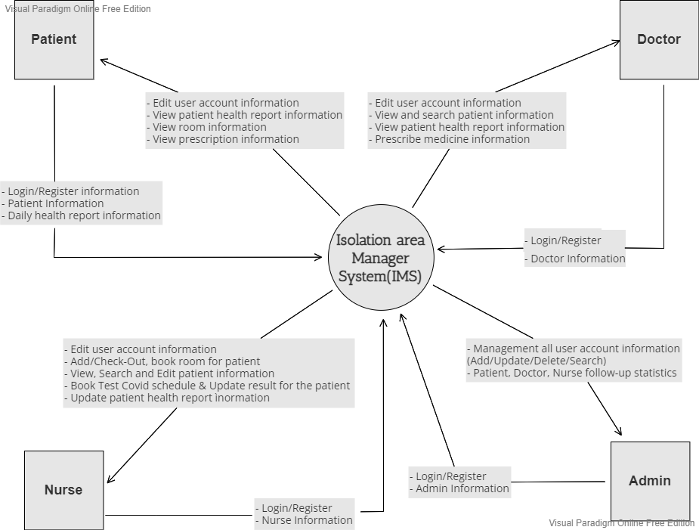

## 2. System Functions

### 2.1. Screen Flow

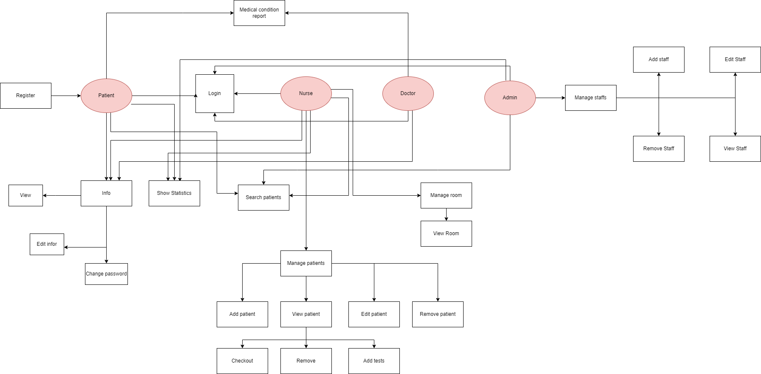

[View details](https://drive.google.com/file/d/14blHGSbqnNXB56RR483b49fFkd6gJrXt/view?usp=sharing)

### 2.2. Screen Details

#### a. Patient

| **#** | **Feature** | **Screen** | **Description** |
| --- | --- | --- | --- |
| 1 | Authenticate user | Login | Log in to the system. |
| 2 | Register | Register a new account. |
| 3 | Manage personal profile | Personal Setting | View profile |
| 4 | Edit Personal Profile | View and edit personal profile. |
| 5 | Change Password | Change old password to new password. |
| 6 | Show Statistics | View patient profile. |
| 7 | Medical Condition | Medical condition report for doctor. |

#### b. Nurse

| **#** | **Feature** | **Screen** | **Description** |
| --- | --- | --- | --- |
| 1 | Manager Patients | Add Patients | Add patients coming from many places. |
| 2 | Search Patients | Searching for patients in isolation. |
| 3 | Edit Patients | Edit the patient's medical status. |
| 4 | Remove Patients | Remove patients who have been released from isolation. |
| 5 | View Patients | CheckOut | Consider releasing the patient from the isolation ward. |
| 6 | Remove | Remove the patient from the quarantine list. |
| 7 | Add Tests | More patient test samples. |
|  | Check Prescribe | Check Prescribe and Dispensing medicine to patients |

#### c. Doctor

| **#** | **Feature** | **Screen** | **Description** |
| --- | --- | --- | --- |
| 1 | Manager Patients |  |  |
| 2 | Search Patients | Searching for patients in isolation. |
| 3 | View Patients | View patient health report |
| 4 |  |  |
| 5 | Prescribe medicine | Prescribe | Prescribe medicine for each patient |

#### d. Admin

| **#** | **Feature** | **Screen** | **Description** |
| --- | --- | --- | --- |
| 1 | Authenticate admin | Login | Log in to the system. |
| 2 | Manager Doctor | Add Doctor | Add doctors for isolation. |
| 3 | View Doctor | View doctor's information and duties. |
| 4 | Edit Doctor | Edit basic information for doctors. |
| 5 | Remove Doctor | Remove doctors from isolation |
| 6 | Manager Nurse | Add Nurse | Add nurses in isolation. |
| 7 | View Nurse | View detailed information about nurses |
| 8 | Edit Nurse | Edit personal information about nurses |
| 9 | Remove Nurse | Remove nurse staff from isolation |
| 10 | Make statistics of medical records | Make statistics of medical records | Statistics of patient history and medical history |

### 2.3. User Authorization

| **No.** | **Screen** | **Patient** | **Nurse** | **Doctor** | **Admin** |
| --- | --- | --- | --- | --- | --- |
| 1 | Login | X | X | X | X |
| 2 | Forgot password | X | X | X | X |
| 3 | Register | X |  |  | X |
| 4 | Personal Setting | X | X | X | X |
| 5 | Edit Personal Profile | X | X | X | X |
| 6 | Search Patient | X | X |  | X |
| 7 | Advance Search |  | X |  | X |
| 8 | Add Patient |  | X |  |  |
| 9 | Edit Patient |  | X |  |  |
| 10 | Remove Patient (Checkout) |  | X |  |  |
| 11 | Add Tests |  | X |  |  |
| 12 | Send Feedback | X |  |  |  |
| 13 | Prescribe |  |  | X |  |
| 14 | View Room |  | X |  | X |
| 15 | Add Nurse |  |  |  | X |
| 16 | Edit Nurse |  |  |  | X |
| 17 | Remove Nurse |  |  |  | X |
| 18 | Add Doctor |  |  |  | X |
| 19 | Edit Doctor |  |  |  | X |
| 20 | Remove Doctor |  |  |  | X |
| 21 | Statistics of patient history |  |  |  | x |
| 22 | Statistics of medical history |  |  |  | x |

In which:

* Role1: <<role1 description>>
* Role2: <<role2 description>>
* …

## 3. Common Requirements

### 3.1. User Requirements

#### a. Actors

| **#** | **Actor** | **Description** |
| --- | --- | --- |
| 1 | Patient | Patient is the person who comes to isolate and send medical condition reports to the nurse. |
| 2 | Doctor | Doctor is the person who can prescribe for patients, let them know their mental health conditions. |
| 3 | Nurse | Nurse is the person whose main job is to manage patients, add tests, check-in, check-out patients, and manage rooms. |
| 4 | Administrator | Admin is the person who has the permission to administer user accounts, see statistics of new coming patients. |

#### 

#### b. Use cases

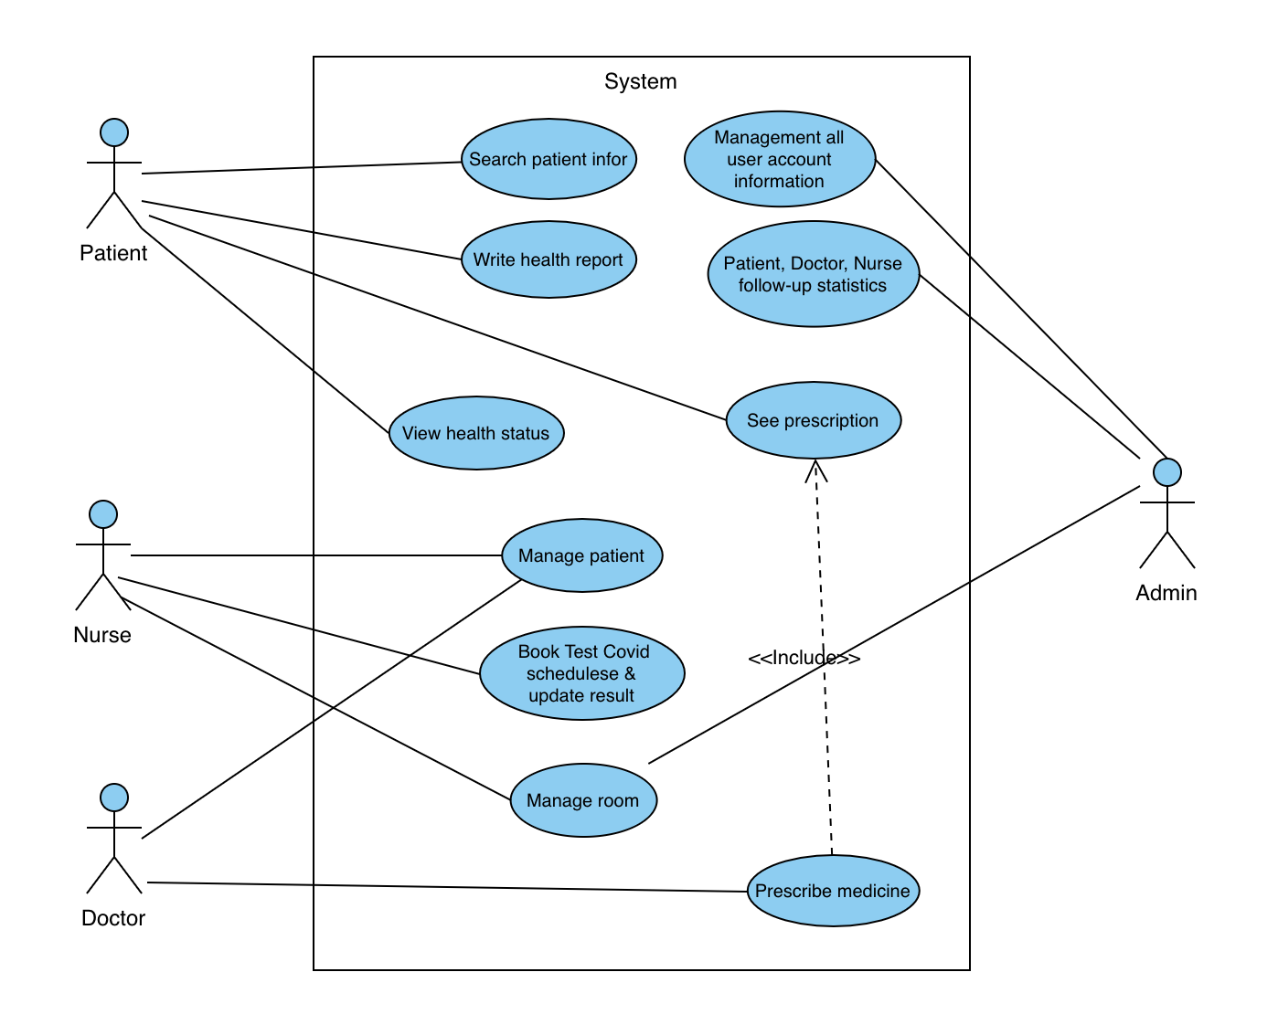

The various user classes identified the following primary actors and use cases for the IMS System:

| **#** | **Actor** | **Description** |
| --- | --- | --- |
| 1 | *Patient* | 1. Searching for patient information  2. Write a daily health report  3. Get daily prescriptions  4. View health status |
| 2 | *Nurse* | 1. Add/Check-Out, book room for patient  2. View, Search, and Edit patient information  3. Book Test Covid schedule & Update result for the patient  4. Update patient health report information  5. Manage room information |
| 3 | *Doctor* | 1. Search patient information  2. View patient health report information  3. Prescribe medicine |
| 4 | *Admin* | 1. Management all user account information (Add/Update/Delete/Search)  2. Patient, Doctor, Nurse follow-up statistics  3. Manage room information |

# II. Functional Requirements

## 1 Function /Login

## 1.1.1 *Screen Design*

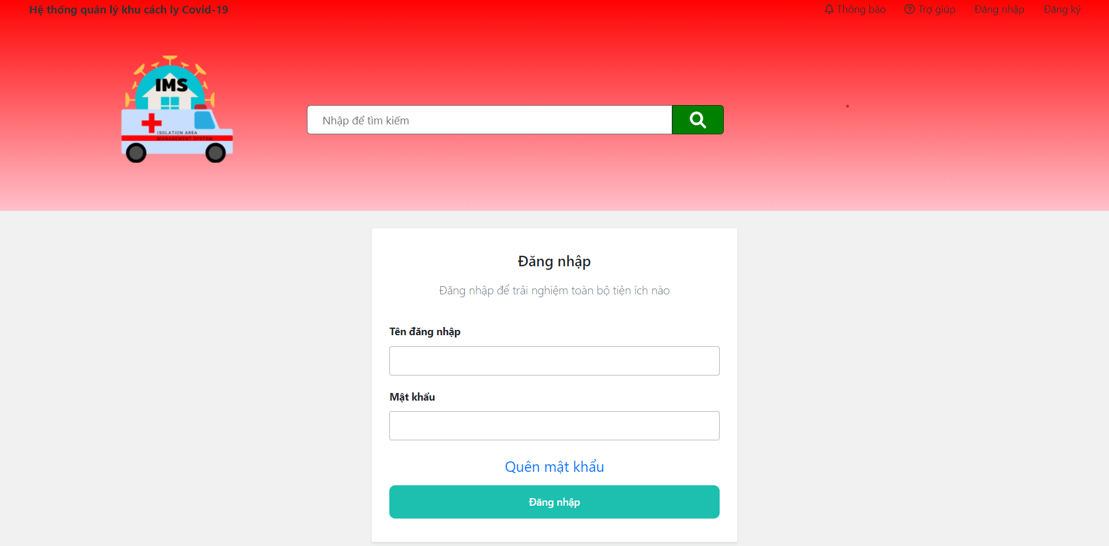

**Figure 2-1**: Screen Design of Login

**Table 1-1: Screen Definition**

| **#** | **Field Name** | **Type** | **Mandatory** | **Max Length** | **Description** |
| --- | --- | --- | --- | --- | --- |
| 1 | Tên đăng nhập | Text | Yes | N/A |  |
| 2 | Mật khẩu | Text | Yes | N/A | Display "*" instead of clear character |
| 3 | Đăng nhập | Button | Yes | N/A | If the username and the password are true go to homepage |
| 4 | Quên mật khẩu | Button |  | N/A | Go to forgot PassWord page |

#### 

## 1.1.2 *Use Case Specification*

| **Use Case ID** | | | **UC01** | |
| --- | --- | --- | --- | --- |
| **Use Name** | | | **Login** | |
| **Actor** | | | User | |
| **Description** | | | The function allows a user to be able to login in the software when he/she has registered an account and his/her account is still active. | |
| **Precondition** | | | User is in website IMS | |
| **Trigger** | | | User clicks on Login button on the header of website | |
| **Post-Condition** | | |  | |

| **Main flows** | | | | |
| --- | --- | --- | --- | --- |
| ***Step*** | ***Actor*** | | ***Action*** | |
| *1* | User | | User clicks on Login button on the header of website | |
| *2* | IMS | | Display Login screen with the following fields:  - Tên đăng nhập  - Mật khẩu  - Đăng nhập button  -Quên mật khẩu button | |
| *3* | User | | Enter Tên đăng nhập & Mật khẩu into Tên đăng nhập & Mật khẩu fields on the Login screen, then click on the Đăng nhập button. | |
| *4* | IMS | | Validate the entered Tên đăng nhập & Mật khẩu and then display Home screen | |
| **Alternative flows** | | | | |
| **AT1** | | At step 2 in the main flows**,** if there is an internal error in the system | | |
| **Sub step** | | **Actor** | | **Action** |
| 2.1 | | IMS | | Display "Error" page with the message "Vui lòng nhập tối thiểu 6 ký tự" |
| **AT2** | | At step 4 in the main flows**,** if MSW failed to validate Tên đăng nhập & Mật khẩu | | |
| **Sub step** | | **Actor** | | **Action** |
| 4.1 | | IMS | | Display "Login" page with the message "Tài khoản không đúng. Vui lòng kiểm tra lại." |

## 2 Function /Register

## 2.1 *Screen Design*

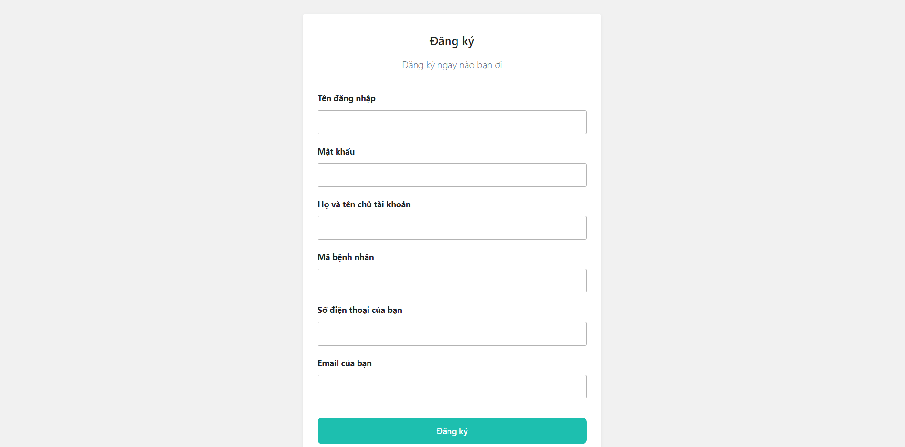

**Figure 2-2**: Screen Design of Register

**Table 2-2: Screen Definition**

| **#** | **Field Name** | **Type** | **Mandatory** | **Max Length** | **Description** |
| --- | --- | --- | --- | --- | --- |
| 1 | Tên đăng nhập | Text | Yes | 20 |  |
| 2 | Mật khẩu | Text | Yes | 20 | Display "*" instead of clear character |
| 3 | Họ và tên chủ tài khoản | Text | Yes | 20 |  |
| 4 | Mã bệnh nhân | Text | Yes | 20 | Show new patient code |
| 5 | Số điện thoại của bạn | Text | Yes | 20 |  |
| 6 | Email của bạn | Text | Yes | 20 |  |
| 7 | Đăng ký | Button |  |  | Go back to the Login page. |

#### 2.1 Use Case Specification

| **Use Case ID** | | | **UC02** | |
| --- | --- | --- | --- | --- |
| **Use Name** | | | **Register** | |
| **Actor** | | | User | |
| **Description** | | | The function allows a user to be able to create a new account | |
| **Precondition** | | | User is in website IMS | |
| **Trigger** | | | User clicks on Sign up on the Login page | |

## 

| **Post-Condition** | | | Tên đăng nhập, Mật khẩu, Họ và tên chủ tài khoản, Mã bệnh nhân,Số điện thoại của bạn,Email của bạn will be added to the database and auto create a new User. | |
| --- | --- | --- | --- | --- |
| **Main flows** | | | | |
| ***Step*** | ***Actor*** | | ***Action*** | |
| *1* | User | | User clicks on Đăng ký on the Login page | |
| *2* | IMS | | Display Login screen with the following fields:  - Tên đăng nhập  - Mật khẩu  - Họ và tên chủ tài khoản  - Mã bệnh nhân  - Số điện thoại của bạn  - Email của bạn  - Đăng ký button | |
| *3* | User | | Enter all fields on the Register screen, then click on the Sign up button. | |
| *4* | IMS | | Validate the entered fields and add to the database then go back to Login page | |
| **Alternative flows** | | | | |
| **AT1** | | At step 2 in the main flows**,** if there is an internal error in the system | | |
| **Sub step** | | **Actor** | | **Action** |
| 2.1 | | IMS | | Display "Error" page with message "Internal System Error, please contact with administrator" |
| **AT2** | | At step 3 in the main flows**,** if the Mã bệnh nhân already existed. | | |
| **Sub step** | | **Actor** | | **Action** |
| 3.1 | | IMS | | Display Register page with message "Bệnh nhân không tồn tại. Vui lòng nhập lại mã" |

## 3 Function /Add Patient

## 3.1 *Screen Design*

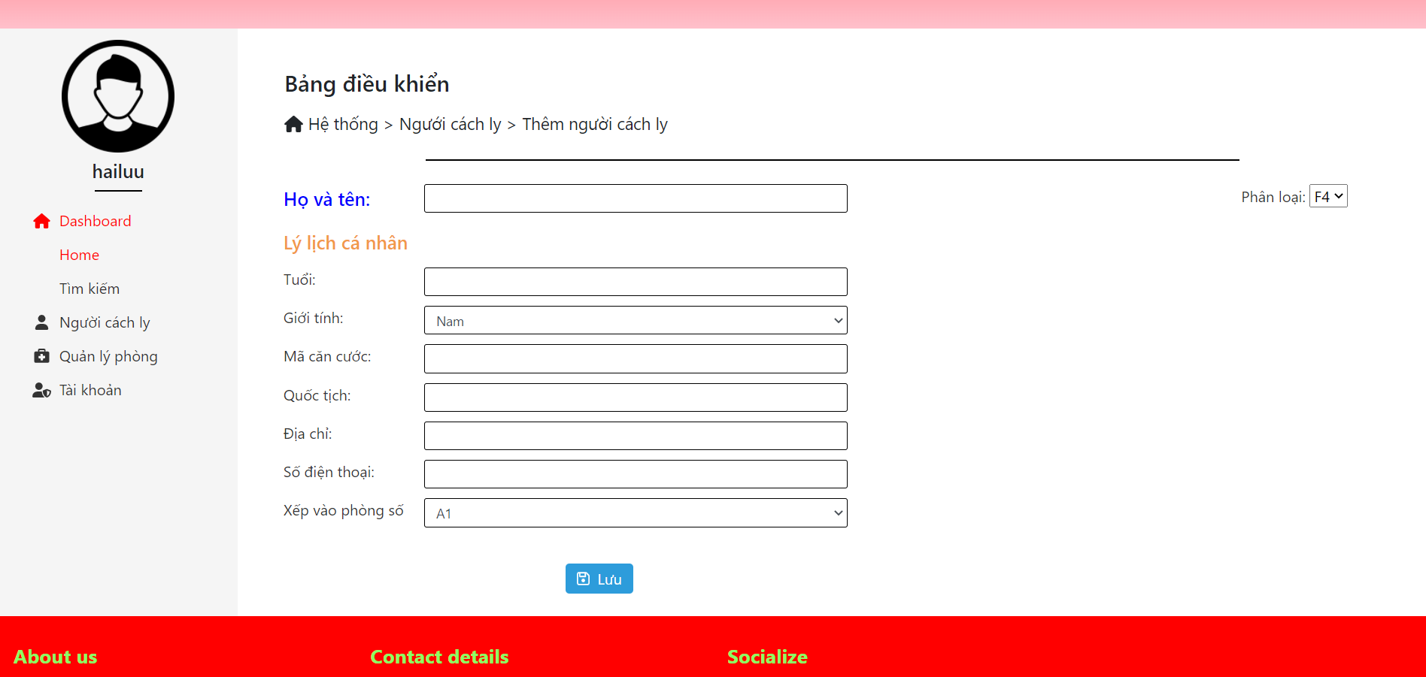

**Figure 2-3**: Screen Design of Add Patient

**Table 3: Screen Definition**

| **#** | **Field Name** | **Type** | **Mandatory** | **Max Length** | **Description** |
| --- | --- | --- | --- | --- | --- |
| 1 | Họ và Tên | Text | Yes | 20 |  |
| 2 | Tuổi | Text | Yes | 20 |  |
| 3 | Giới tính | Checkbox | Yes | 20 | Show default “Nam” |
| 4 | Mã căn cước | Text | Yes | 20 |  |
| 5 | Quốc tịch | Text | Yes | 20 |  |
| 6 | Địa chỉ | Text | Yes | 20 |  |
| 7 | Số điện thoại | Text | Yes | 20 |  |
| 8 | Xếp vào phòng số | Checkbox | Yes |  | Show room type |
| 9 | Lưu | Button |  |  | Go back to the Patient manager page. |

#### 3.2 Use Case Specification

| **Use Case ID** | | | **UC03** | |
| --- | --- | --- | --- | --- |
| **Use Name** | | | **Add Patient** | |
| **Actor** | | | Nurse | |
| **Description** | | | The function allows a Nurse to be able to create a new Patient | |
| **Precondition** | | | Nurse is in website IMS | |
| **Trigger** | | | Nurse clicks on Lưu button on the Patient manager page | |

| **Post-Condition** | | | Họ và Tên, Tuổi, Giới tính, Mã bệnh nhân,Mã căn cước,Quốc tịch,Địa chỉ,Số điện thoại,Xếp vào phòng số will be added to the database and auto create a new Patient. | |
| --- | --- | --- | --- | --- |
| **Main flows** | | | | |
| ***Step*** | ***Actor*** | | ***Action*** | |
| *1* | Nurse | | User clicks on Lưu on the Patient manager page | |
| *2* | IMS | | Display Patient manager screen with the following fields:  - Họ và Tên  - Tuổi  - Giới tính  - Mã căn cước  - Quốc tịch  - Địa chỉ  - Số điện thoại  - Xếp vào phòng số  - Lưu button | |
| *3* | Nurse | | Enter all fields on the Add Patient screen, then click on the Lưu button. | |
| *4* | IMS | | Validate the entered fields and add to the database then go back to Patient manager page. | |
| **Alternative flows** | | | | |
| **AT1** | | At step 2 in the main process, if the Internal information in system | | |
| **Sub step** | | **Actor** | | **Action** |

| 2.1 | | IMS | | Display "Vui lòng điền vào trường này" |
| --- | --- | --- | --- | --- |
| **AT2** | | At step 4 in the main flows | | |
| **Sub step** | | **Actor** | | **Action** |
| 3.1 | | IMS | | Display Register page with message "Thêm người cách ly thành công " |

## 4 Function /Remove Patient

## 4.1 *Screen Design*

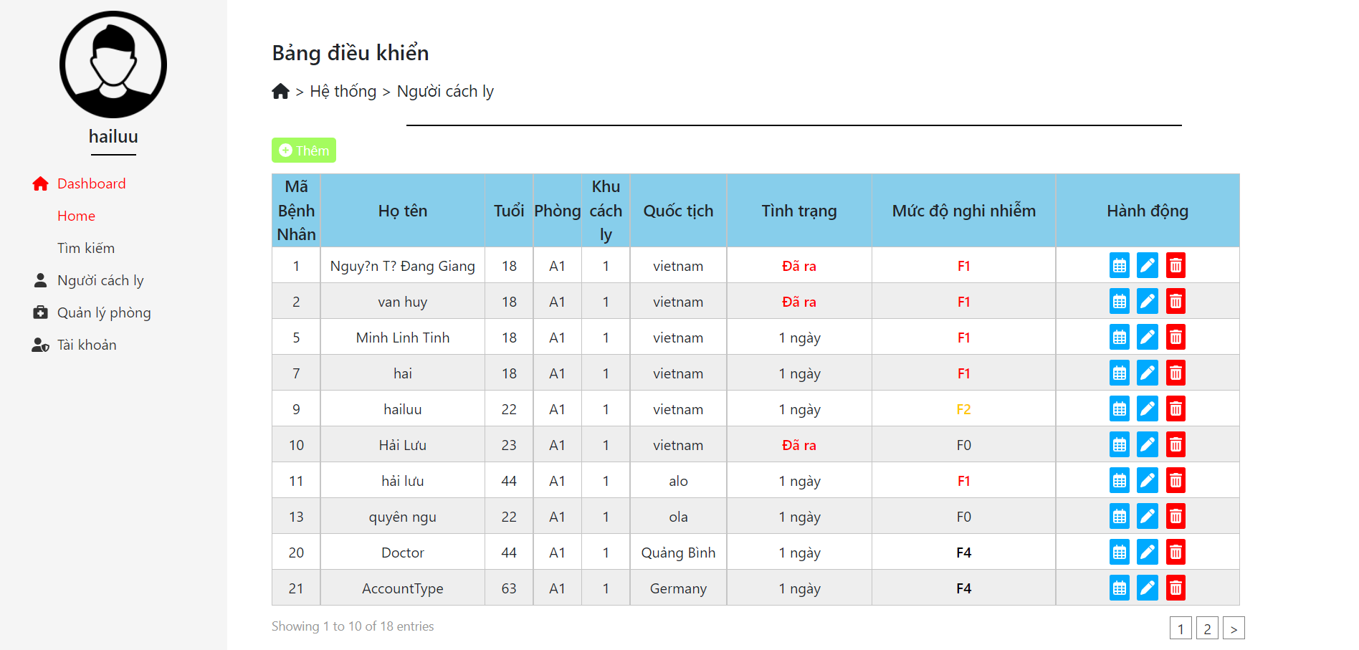

**Figure 2-4**: Screen Design of Remove Patient

## 

**Table 4: Screen Definition**

| **#** | **Field Name** | **Type** | **Mandatory** | **Max Length** | **Description** |
| --- | --- | --- | --- | --- | --- |
| 1 | Icon | Button | Yes |  |  |

#### 4.2 Use Case Specification

| **Use Case ID** | | | **UC04** | |
| --- | --- | --- | --- | --- |
| **Use Name** | | | **Remove Patient** | |
| **Actor** | | | Nurse | |
| **Description** | | | The function allows Nurse remove Patient. | |
| **Precondition** | | | Nurse is in website IMS | |
| **Trigger** | | | Nurse clicks on the Icon Delete button. | |
| **Post-Condition** | | |  | |
| **Main flows** | | | | |
| ***Step*** | ***Actor*** | | ***Action*** | |
| *1* | Nurse | | Nurse clicks on the Icon Delete button . | |
| *2* | IMS | | Remove Patient in database and go back to the Patient manager page | |
| **Alternative flows** | | | | |
| **AT1** | | At step 2 in the main flows**,** if there is an internal error in the system, | | |
| **Sub step** | | **Actor** | | **Action** |
| 2.1 | | MSW | | Display "Error" page with message "Internal System Error, please contact with administrator" |

## 5 Function /Update Patient

## 5.1 *Screen Design*

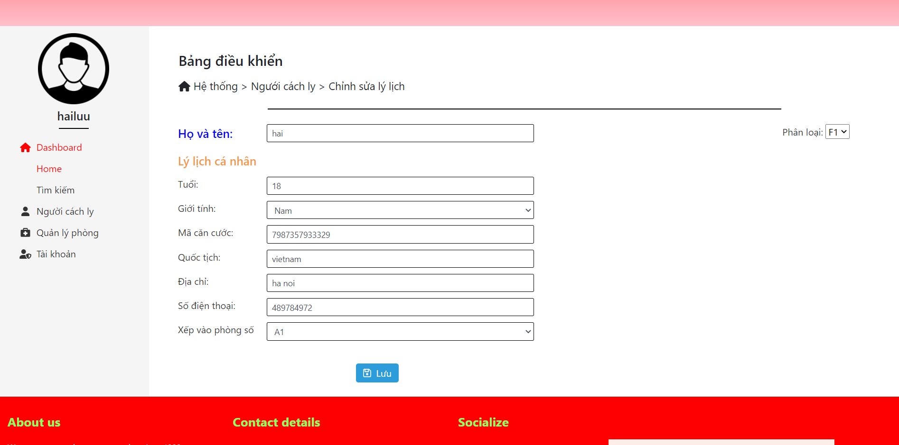

**Figure 2-5**: Screen Design of Edit Patient

**Table 5: Screen Definition**

| **#** | **Field Name** | **Type** | **Mandatory** | **Max Length** | **Description** |
| --- | --- | --- | --- | --- | --- |
| 1 | Họ và Tên | Text | Yes | 20 | Display full name |
| 2 | Tuổi | Text | Yes | 20 | Display age |
| 3 | Giới tính | Checkbox | Yes | 20 | Show default “Nam” |
| 4 | Mã căn cước | Text | Yes | 20 | Display ID code |
| 5 | Quốc tịch | Text | Yes | 20 | Display nationality |
| 6 | Địa chỉ | Text | Yes | 20 | Display address |
| 7 | Số điện thoại | Text | Yes | 20 | Display phone number |
| 8 | Xếp vào phòng số | Checkbox | Yes |  | Show room type |
| 9 | Lưu | Button |  |  | Go back to the Patient manager page. |

#### 5.2 Use Case Specification

| **Use Case ID** | | | **UC05** | |
| --- | --- | --- | --- | --- |
| **Use Name** | | | **Update Patient** | |
| **Actor** | | | Nurse | |
| **Description** | | | The function allows Nurse Edit Patient. | |
| **Precondition** | | | Nurse clicks on the text edit information Patient | |
| **Trigger** | | | Nurse clicks on the Lưu button save. | |
| **Post-Condition** | | | Information will changed after Nurse save | |
| **Main flows** | | | | |
| ***Step*** | ***Actor*** | | ***Action*** | |
| *1* | Nurse | | Nurse clicks on the text edit information Patient | |
| *2* | IMS | | Display information screen with the following fields:  - Họ và Tên  - Tuổi  - Giới tính  - Mã căn cước  - Quốc tịch  - Địa chỉ  - Số điện thoại  - Xếp vào phòng số | |
| *3* | Nurse | | Enter Lưu button save information. | |
| *4* | IMS | | Display Patient manager page. | |
| **Alternative flows** | | | | |
| **AT1** | | At step 2 in the main flows**,** if there is an internal error in the system, | | |
| **Sub step** | | **Actor** | | **Action** |
| 2.1 | | IMS | | Display "Error" page with message "Internal System Error, please contact with administrator" |
| **AT2** | | At step 3 in the main flowsafter save | | |
| **Sub step** | | **Actor** | | **Action** |
| 5.1 | | IMS | | Display "cập nhật thành công" |

## 6 Function /Add Test

## 6.1 *Screen Design*

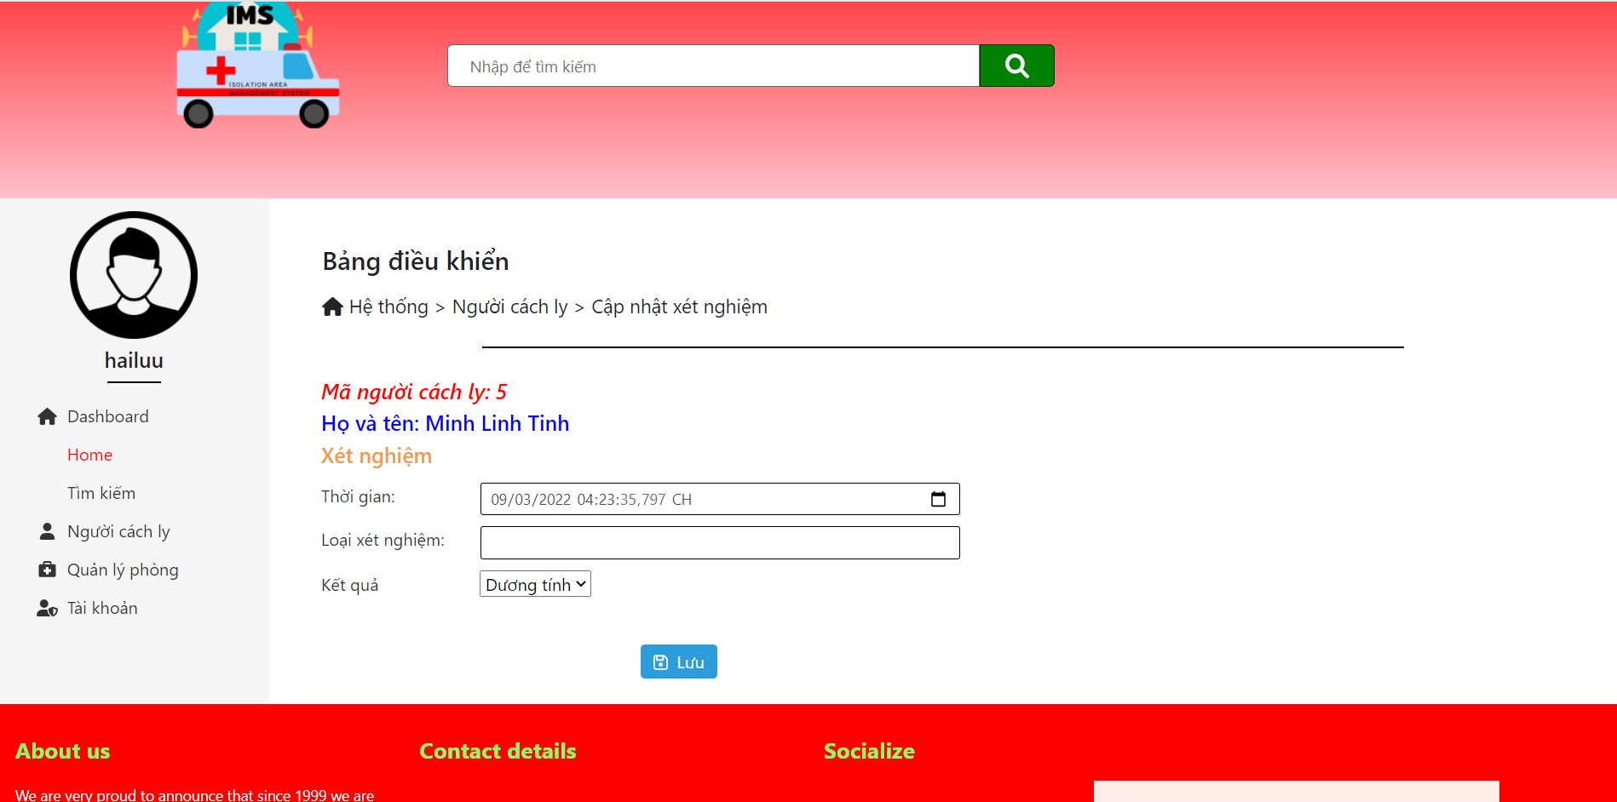

**Figure 2-6**: Screen Design of Add Test

**Table 6: Screen Definition**

| **#** | **Field Name** | **Type** | **Mandatory** | **Max Length** | **Description** |
| --- | --- | --- | --- | --- | --- |
| 1 | Thời gian | DateTime | Yes |  | Display time |
| 2 | Loại xét nghiệm | Text | Yes | 20 |  |
| 9 | Lưu | Button |  |  | Go back to the view information Patient page. |

#### 

#### 6.2 Use Case Specification

| **Use Case ID** | | | **UC06** | |
| --- | --- | --- | --- | --- |
| **Use Name** | | | **Add Test** | |
| **Actor** | | | Nurse | |
| **Description** | | | The function allows Nurse Add Test Patient. | |
| **Precondition** | | | Nurse clicks on the text edit Test Patient | |
| **Trigger** | | | Nurse clicks on the Lưu button save. | |
| **Post-Condition** | | | Information will changed after Nurse save | |
| **Main flows** | | | | |
| ***Step*** | ***Actor*** | | ***Action*** | |
| *1* | Nurse | | Nurse clicks on the text Add Test Patient | |
| *2* | IMS | | Display information Test for Patient screen with the following fields:  - Thời gian  - Loại xét nghiệm | |
| *3* | Nurse | | Enter Lưu button save information. | |
| *4* | IMS | | Display detail Patient manager page. | |
| **Alternative flows** | | | | |
| **AT1** | | At step 2 in the main flows**,** if there is an internal error in the system, | | |
| **Sub step** | | **Actor** | | **Action** |
| 2.1 | | IMS | | Display "Error" page with message "Internal System Error, please contact with administrator" |
| **AT2** | | At step 4 in the main flowsafter save | | |
| **Sub step** | | **Actor** | | **Action** |
| 5.1 | | IMS | | Display "cập nhật thành công" |

## 7 Function /Discharge

## 7.1 *Screen Design*

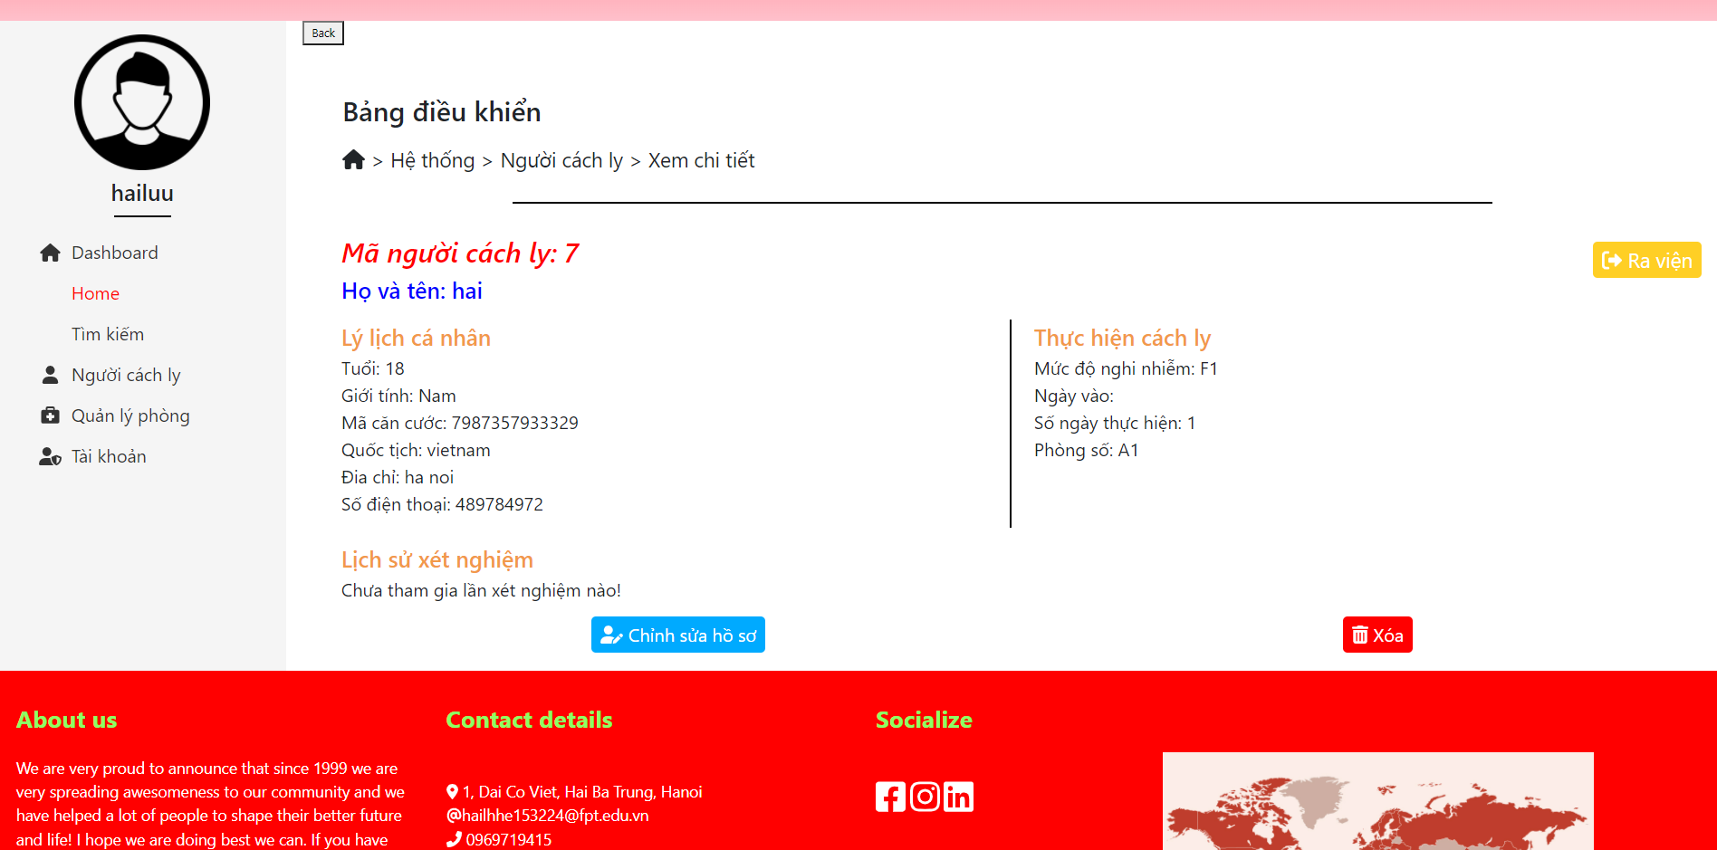

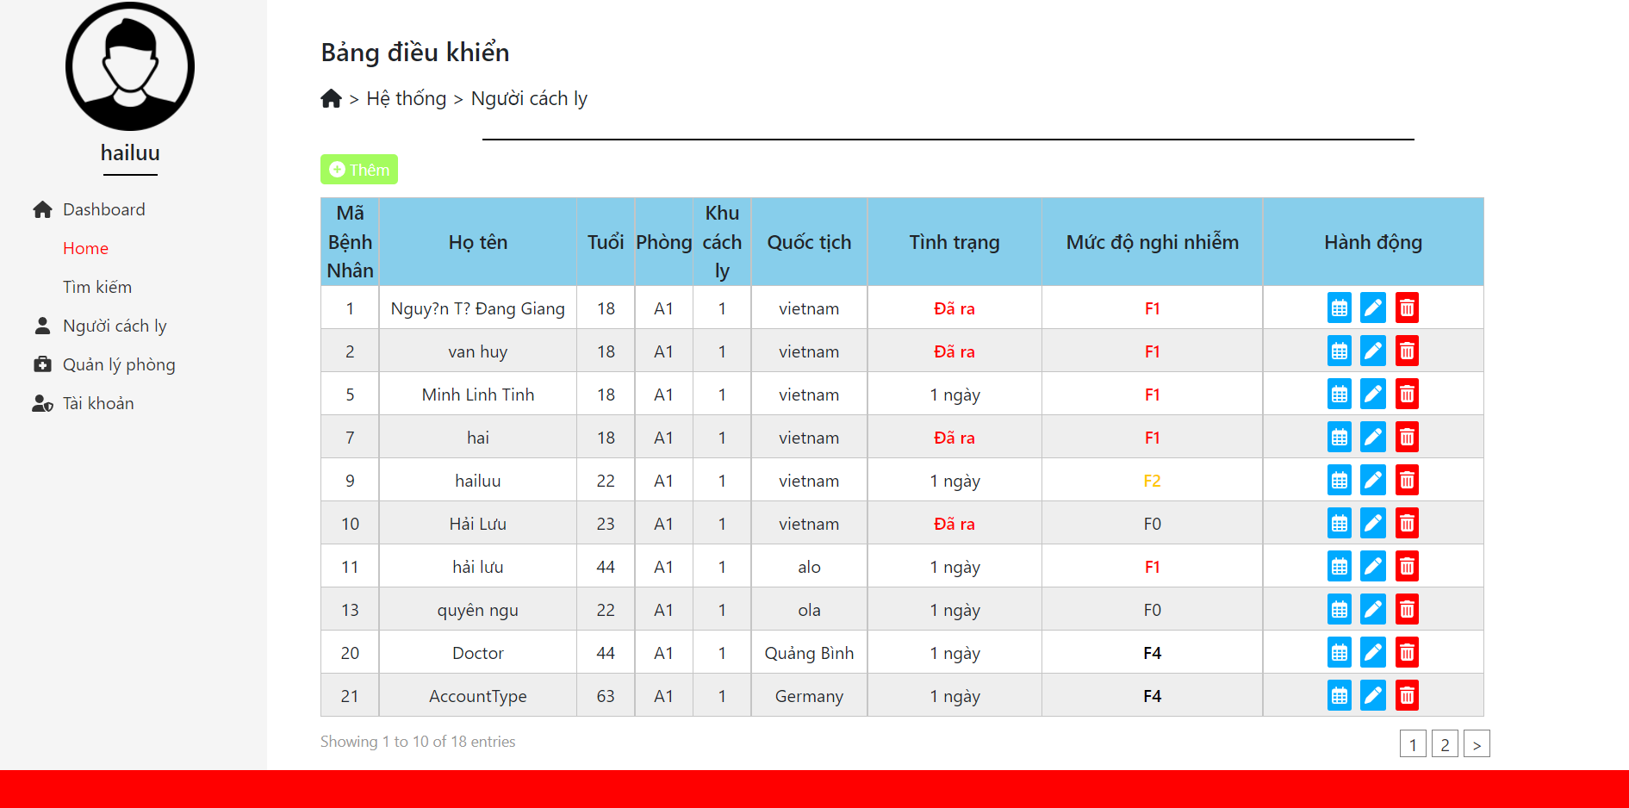

**Figure 2-7**: Screen Design of Discharge

**Table 7: Screen Definition**

| **#** | **Field Name** | **Type** | **Mandatory** | **Max Length** | **Description** |
| --- | --- | --- | --- | --- | --- |
| 1 | Ra viện | Button |  |  | Click to button |

#### 

#### 7.2 Use Case Specification

| **Use Case ID** | | | **UC07** | |
| --- | --- | --- | --- | --- |
| **Use Name** | | | **Discharge** | |
| **Actor** | | | Nurse | |
| **Description** | | | The function allows Nurse view and have click discharge Patient. | |
| **Precondition** | | | Nurse clicks on the button discharge Patient | |
| **Trigger** | | |  | |
| **Post-Condition** | | | Information will changed after Nurse click discharge | |
| **Main flows** | | | | |
| ***Step*** | ***Actor*** | | ***Action*** | |
| *1* | Nurse | | Nurse clicks button “Ra viện”Patient | |
| *2* | IMS | | Display information screen Patient Discharge with the following fields:  - collor red | |
| **Alternative flows** | | | | |
| **AT1** | | At step 2 in the main flows**,** if there is an internal error in the system, | | |
| **Sub step** | | **Actor** | | **Action** |
| 2.1 | | IMS | | Display "Error" page with message "Internal System Error, please contact with administrator" |
| **AT2** | | At step 2 in the main flowsafter save | | |
| **Sub step** | | **Actor** | | **Action** |
| 5.1 | | IMS | | Display "Đã ra" |

## 8 Function /Create Room

## 7.1 *Screen Design*

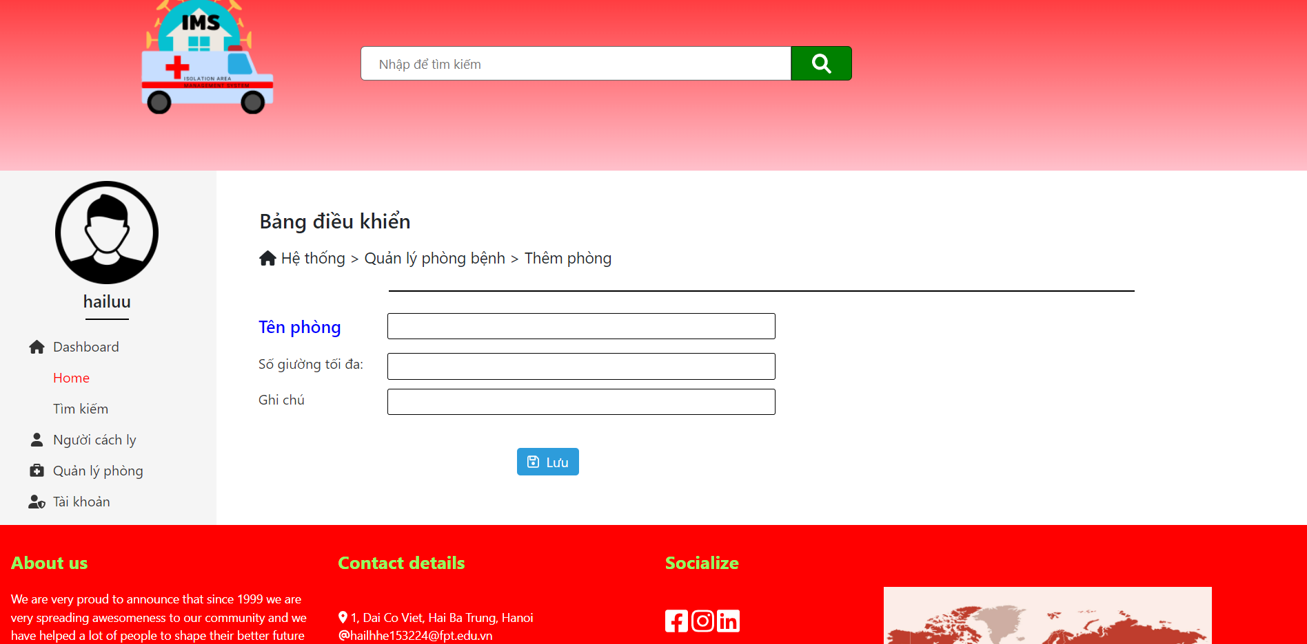

**Figure 2-8**: Screen Design of Create Room

**Table 8: Screen Definition**

| **#** | **Field Name** | **Type** | **Mandatory** | **Max Length** | **Description** |
| --- | --- | --- | --- | --- | --- |
| 1 | Tên Phòng | Text | Yes | 20 |  |
| 2 | Số giường tối đa | Text | Yes | 20 |  |
| 3 | Ghi chú | Text | Yes | 20 |  |
| 4 | Lưu | Button |  |  |  |

#### 

## 9 Function /Update Room

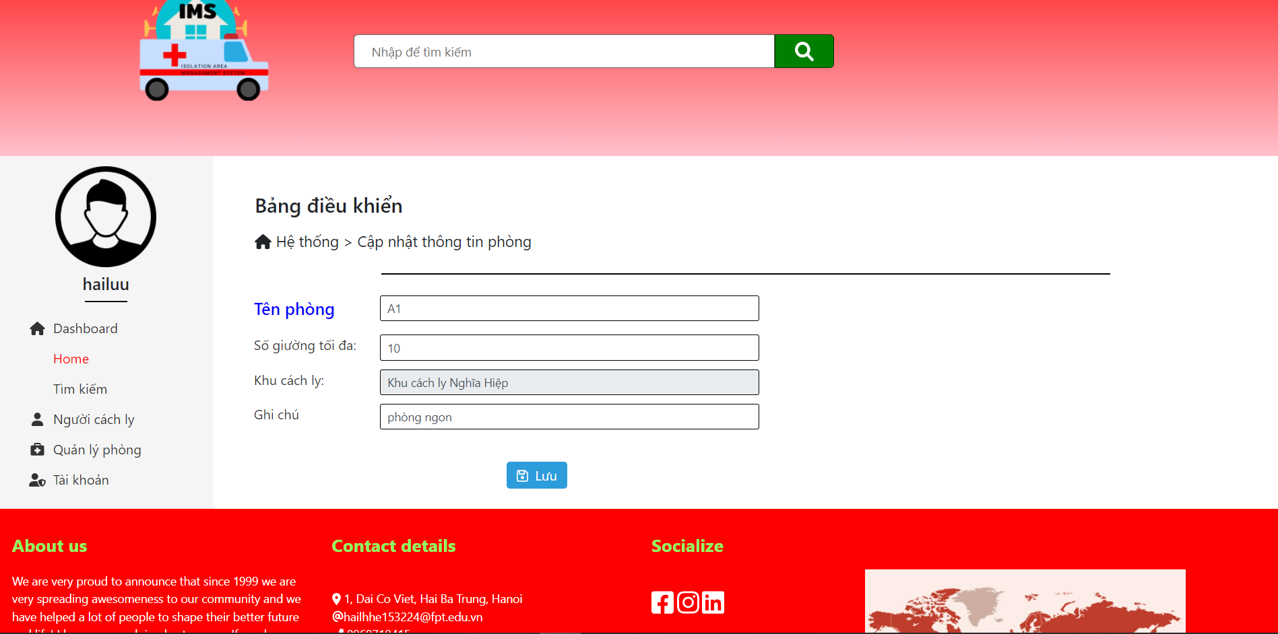

Cập nhật phòng cách ly thành công.

## 10 Function /Delete Room

